**Project Name:** License Plate Detection

**Github Link:** https://github.com/projectsforstudents2022/License-Plate-Detection.git

**Why was this project created?**

Identification of the area of the vehicle thought to be the license plate is known as license plate detection. Identification of the values that make up the license plate is recognition. The method known as "license plate detection and recognition" makes use of computer vision to find and identify a license plate from an input image of an automobile. This technique has several applications. It is used to track down vehicles that are violating traffic laws on the road. It is used in security to record the license plates of the cars entering and exiting certain locations. It is used to record the license plates of the vehicles parked in parking lots. The number of its uses is endless.

**What problem is it solving?**

The goal is to create a successful automatic approved vehicle identification system that makes use of the license plate. The system is put in place at the entry to regulate security in highly restricted areas like military zones or the vicinity of important government buildings like the Supreme Court, Parliament, and so on.

**Entire explanation of project**

* **PROPOSED APPROACH**

The first step entails taking a picture with the USB camera attached to the computer. The photos are taken in RGB format so that number plate extraction may be done afterwards. Extraction of the number plate from an image is the second phase of the ANPR algorithm. In order to extract the probability ROI in a picture, a yellow search method is used. Since Sindh's official license plate has a yellow backdrop and black alphanumeric characters, it is simple to identify the plate region by looking for yellow pixels. The yellow color or certain pixels that are closer to yellow in value are sought after in the image. The value of the pixel is set to 1 if it is yellow; else, it is set to 0.

The vehicle number is recognised in the third phase of the proposed ANRP algorithm using the Optical Character Recognition (OCR) technique. The cropped picture that is produced as a consequence of the second step is inverted, meaning that all of the white pixels are turned into black and all of the black pixels into white. Currently, the plate backdrop is black with white writing. The text is divided into its constituent lines using the line separation procedure before OCR is used. The value of each pixel in a row is added by the line spacing. If the resulting total of a row is 0, there are no text pixels in that row, and if it is larger than zero, there are text pixels in that row.and the default parameters. We evaluate our model's performance using a test dataset.

Algorithm for creating next word prediction model :

**Step 1:** Capture Image

**Step 2:** Image Filtering

**Step 3:** Plate Region Extraction

**Step 4:** Segmentation

**Step 5:** OCR for Character Recognition

**Step 6:** Prediction

* **DATA FLOW DIAGRAM**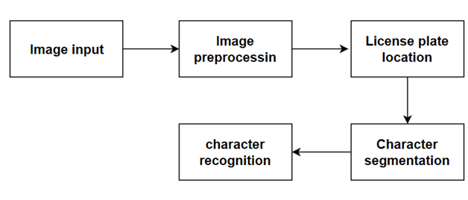
* **RESULT**

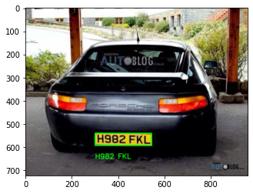

* **CONCLUSION**

The system uses a variety of image processing methods to extract the car from the PC's database. The system is created in Python, and actual photos are used to evaluate the system's performance. The simulation findings demonstrate that the system may be installed at the entry to a highly restricted area and can reliably detect and identify a vehicle using its license plate under a variety of lighting conditions.